**18CS2205R – DATABASE MANAGEMENT SYSTEMS**

**PROJECT BASED REPORT**

**ON**

**BLOOD DONATION MANAGEMENT SYSTEM**

**submitted in partial fulfillment of the requirement for the award of the degree of**

**BACHELOR OF TECHNOLOGY**

**In**

**COMPUTER SCIENCE AND ENGINEERING**

**By**

TULABANDU MANI SHANKAR (180030374)

Section-08

Under the Esteemed Guidance of



**DEPARTMENT OF COMPUTER SCIENCE AND ENGINEERING**

**K L (Deemed to be) University**

Green Fields, Vaddeswaram, Guntur District – 522 502

**(2019-2020)**

**ABOUT THE PROJECT:**

Blood Donation Management System is a software application system application to maintain day to day transactions in a blood bank. This software help to register all the donars , Blood Collection details , blood issued details etc…..

**AIM OF THE PROJECT:**

The aim of the project is to design a database using SQL commands. The tables have to created as per the topic of the project, insert five values in each of them and perform various SQL operations.

**SOFTWARE REQUIRED:**

1. Run SQL Command Line

**IMPLEMENTATION:**

The implementation has 3 parts in it.,

1. Table creation
2. Values insertion
3. Queries

According to the project, we have five tables created. They are.,

1. Donar Register
2. Reciptent Register
3. Admin login
4. Request to donar
5. Donate to recieptent

**CODE:**

SQL> connect

Enter user-name: mani

Enter password: mani

Connected.

**-------TABLE CREATION------**

create table donarRegister(ename varchar2(40),dof varchar2(20),did number primary key,Fname varchar2(20),Lname varchar2(20),code number (6),phone number(10), uname varchar2(20), pass varchar2(20),Rpass varchar2(20));

create table ReciptentRegister(ename varchar2(40),dof varchar2(20),did number primary key,Fname varchar2(20),Lname varchar2(20),Hname varchar2(30),code number (6),phone number(10), uname varchar2(20), pass varchar2(20),Rpass varchar2(20));

create table adminlogin(uname varchar2(5),pass varchar2(5));

create table requestToDonar(DonarId number,mesg varchar2(1000));

create table DonateToReciptent(Reciptent_id number ,mesg varchar2(1000));

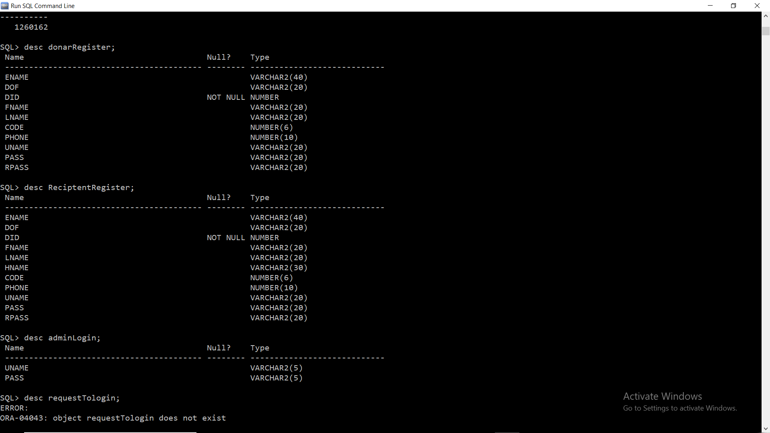

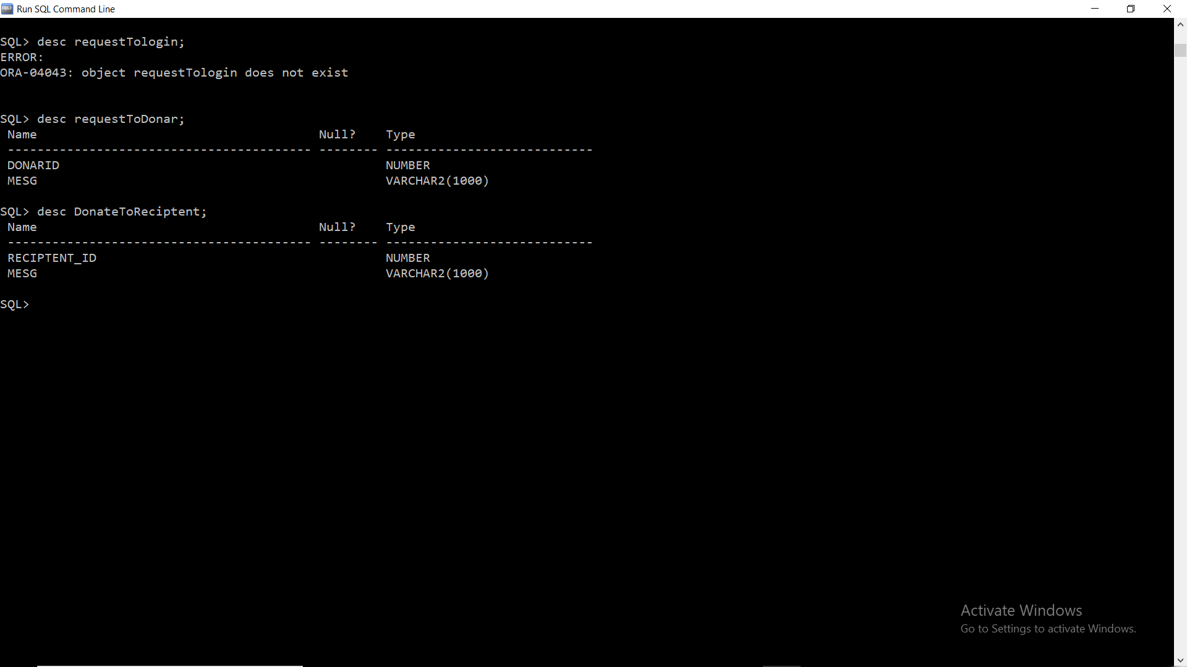

**------INSERTING VALUES-----**

Insert into donarRegister values(‘&ename’, ‘&dof’,&did, ‘&Fname’, ‘&Lname’,&code,&phone, ‘&uname’, ‘&pass’, ‘&Rpass’);

insert into ReciptentRegister (‘&ename’, ‘&dof’,&did, ‘&Fname’, ‘&Lname’, ‘&Hname’,&code,&phone, ‘&uname’, ‘&pass’, ‘&Rpass’);

insert into adminLogin values(‘&uname’, ‘&pass’);

insert into requestToDonar values(&Donar_id, ‘&mesg’);

insert into DonateToReciptent values(&Reciptent_id, ‘&mesg’);

SQL> **select * from donarRegister ;**

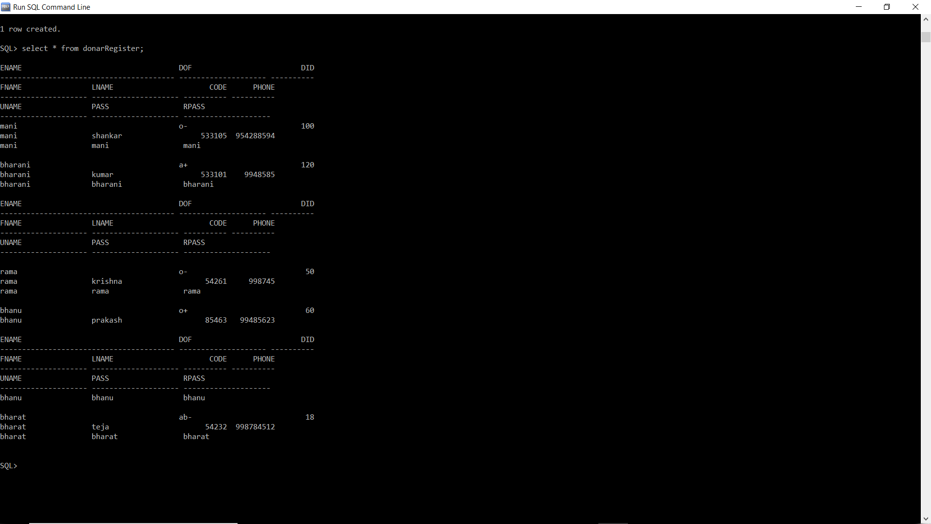

SQL> **select * from ReciptentRegister;**



SQL> **select * from adminLogin;**



SQL> **select * from requestToDonar;**

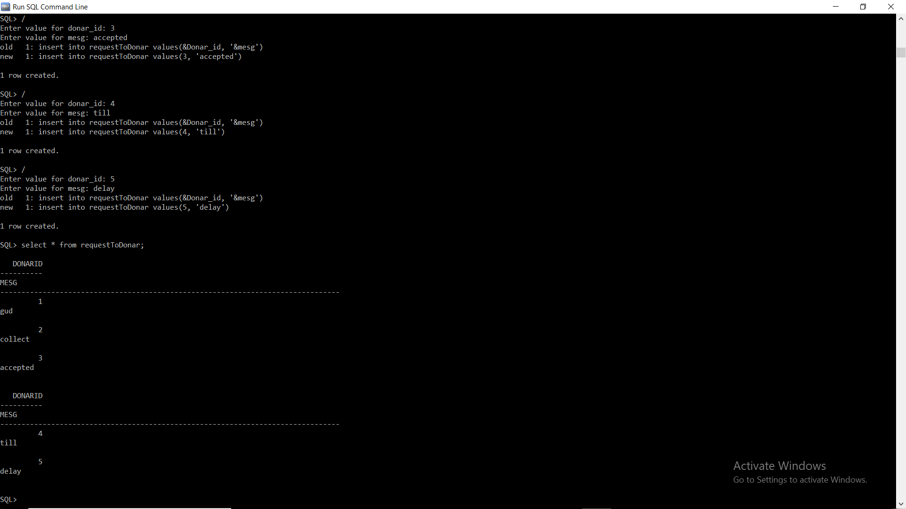

SQL> **select * from DonateToReciptent;**

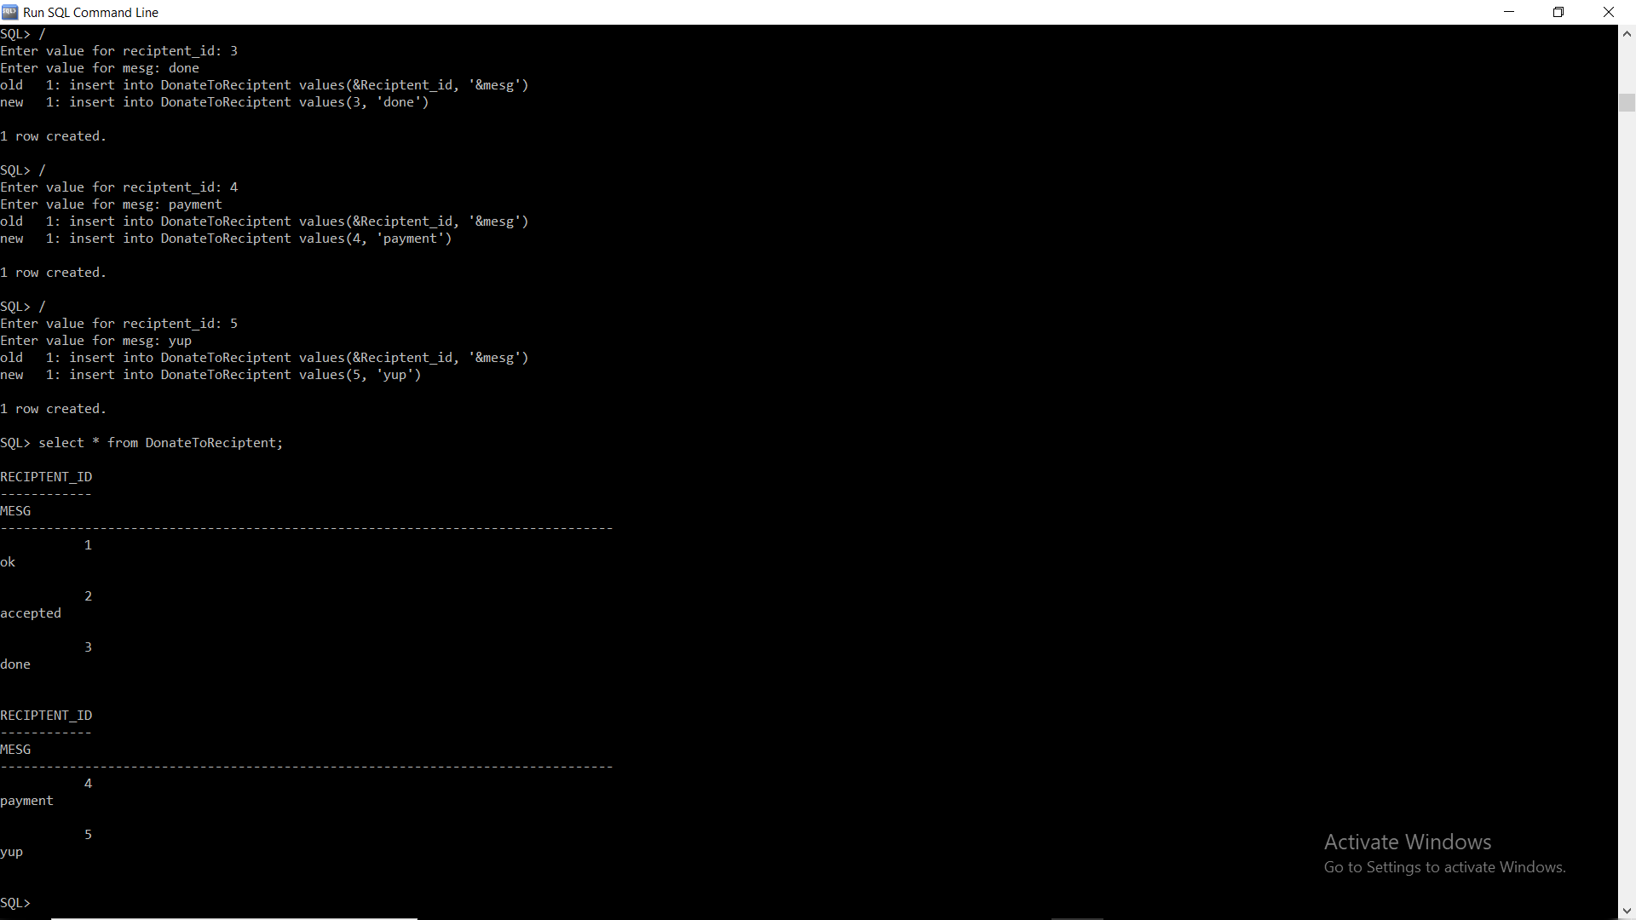

**------QUERIES----**

**1.union:**

select ename,did from reciptentRegister union select ename,did from donarregister;

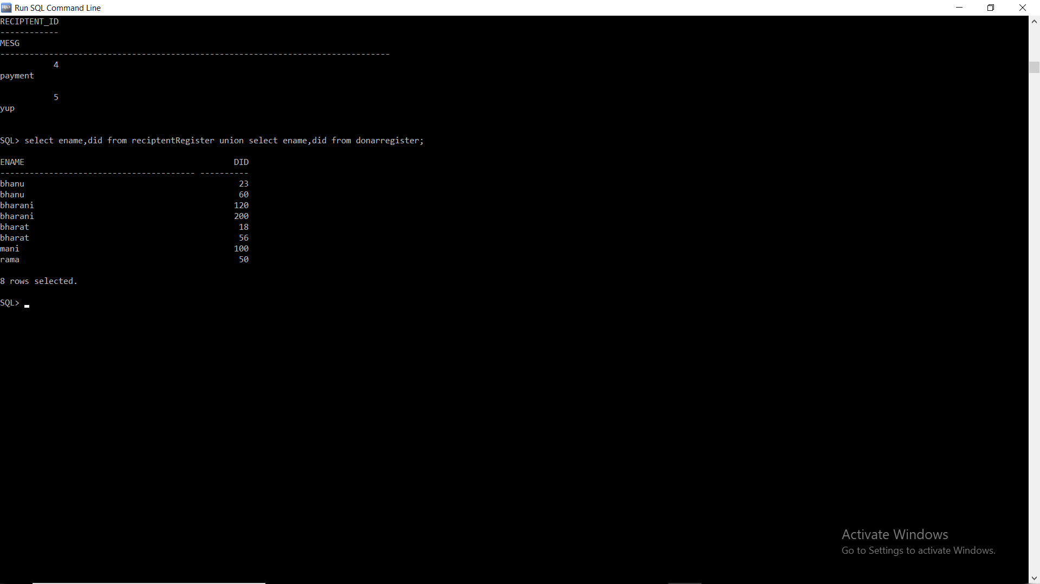

**2.join:**

select reciptentRegister.did,donarRegister.did,reciptentRegister.dof from reciptentRegister INNER JOIN DonarRegister ON DonarRegister.dof=ReciptentRegister.dof;

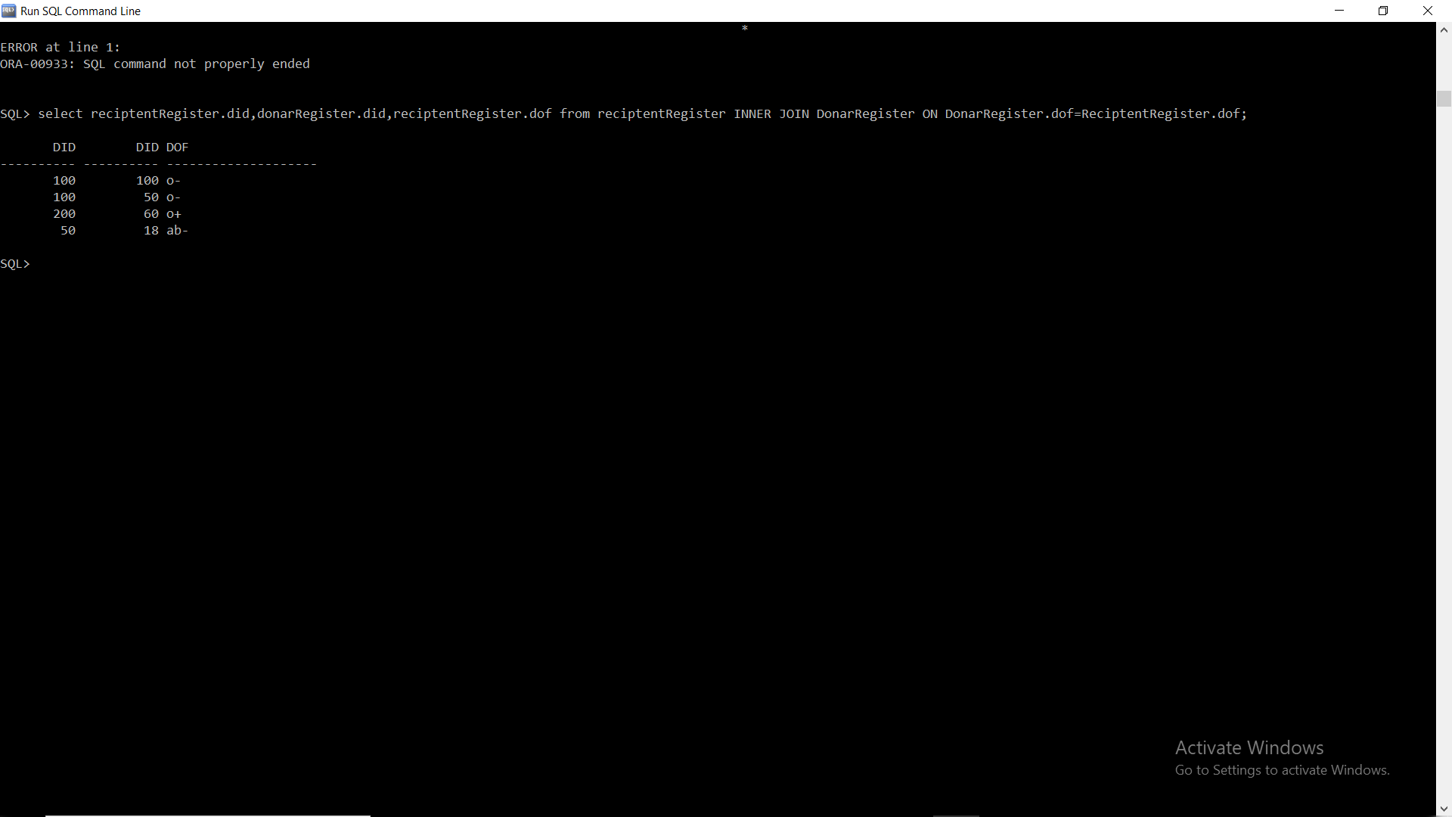

**3.Aggregate functions:count( ):-**

Select count(did) from reciptentRegister;

Select count(did) from donarRegister;



**4.Aggregate function:order by:-**

select did,uname from reciptentRegister order by did;

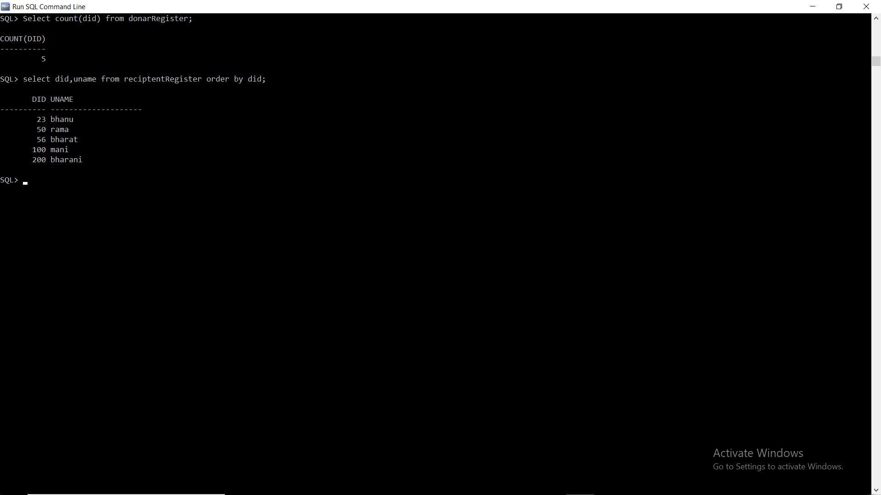

**5.Aggregate function:update:-**

update ReciptentRegister set pass='shankar' where uname='mani';

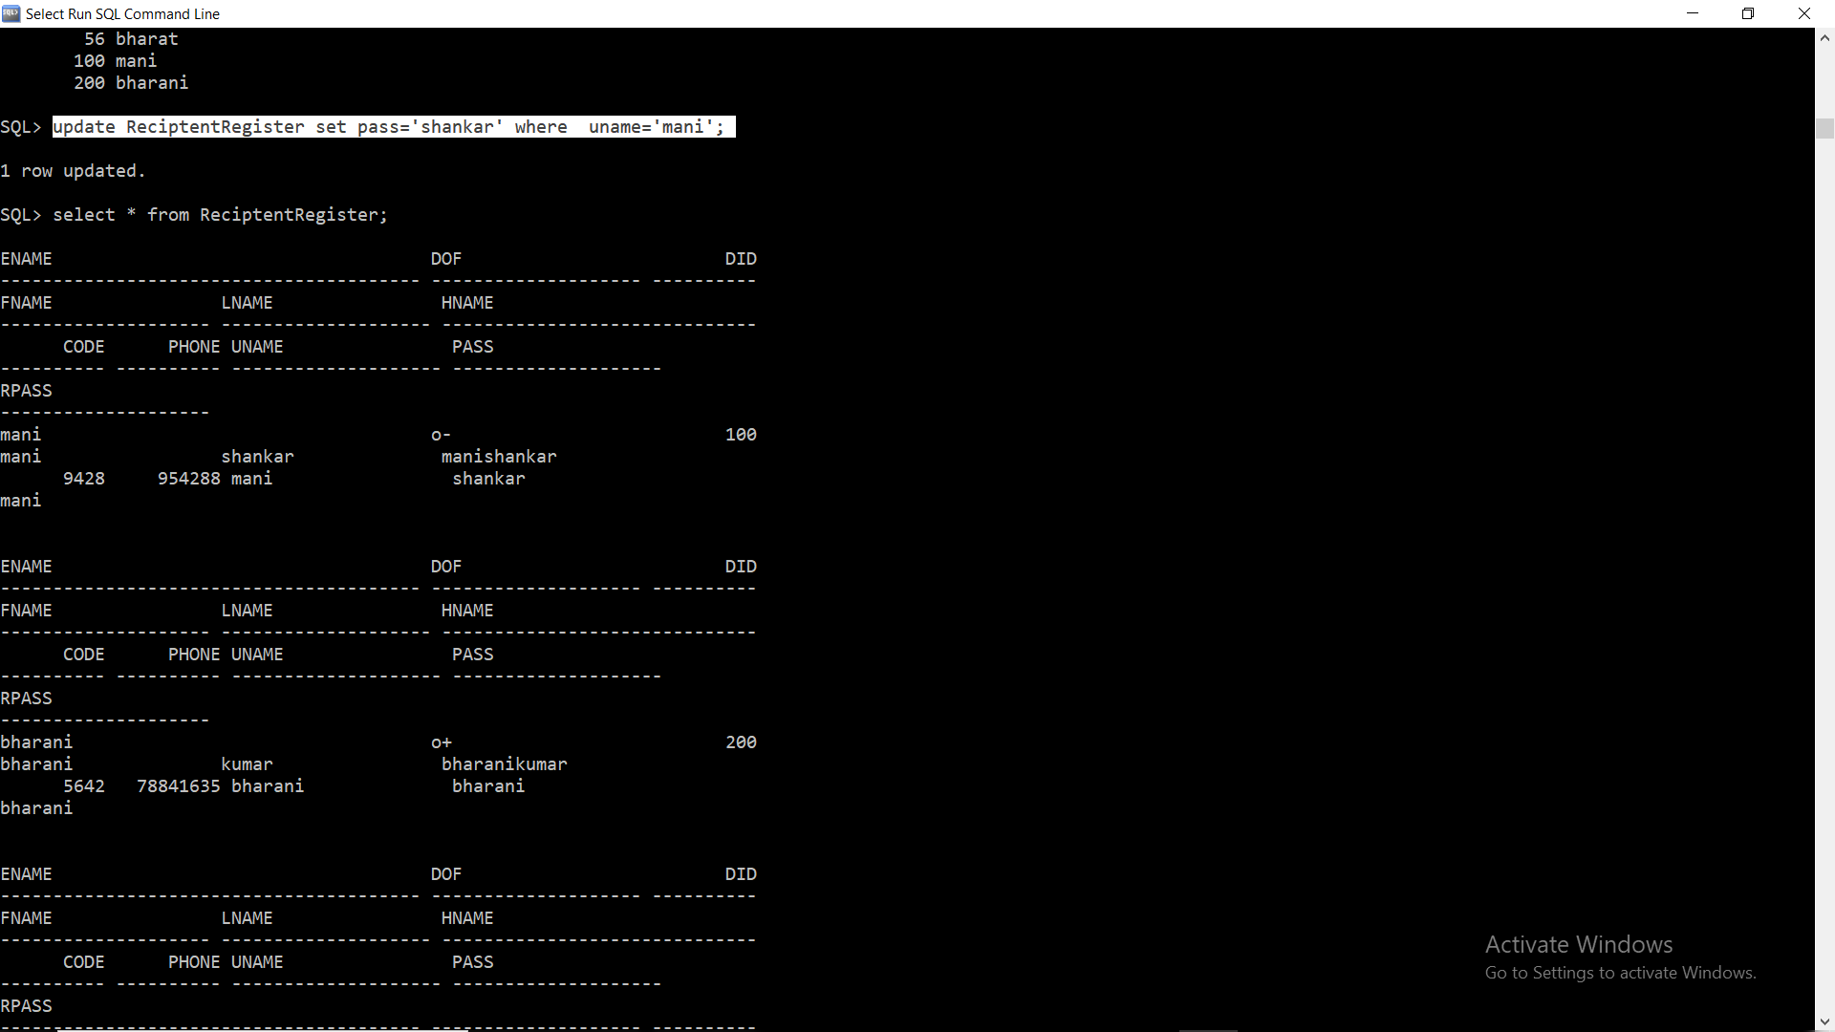

**6.Aggregate function:group by clause:-**

select count(hname),hname from reciptentRegister group by hname;



**7.Aggregate Function:avg():-**

**8.Aggregate Function:Max():-**

**9.Aggregate Function:Min():-**

**10.Aggregate Function:Sum():-**

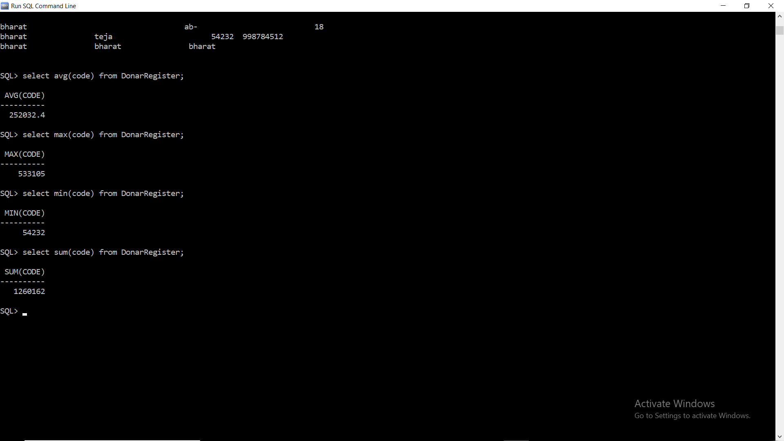

**CONCLUSION:**

From this project, we have learnt how to design a database based on the given conditions and execute the same successfully on Run SQL Command line.